**Uncertainty in AI**

To discuss questions from previous exams

Improve with green please

Exam 2021

Question 1

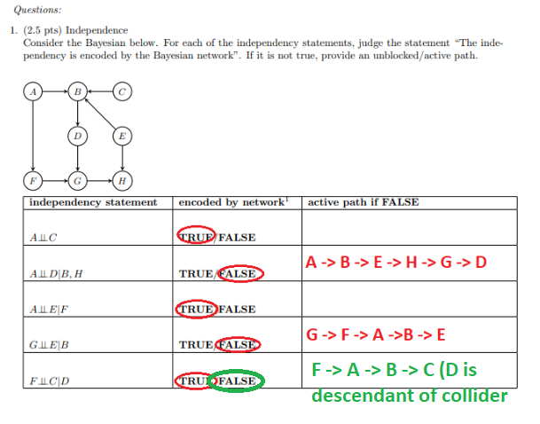

Shouldn’t the last one be False (F-A-B-C, B is a collider with a descendant in the conditioning set)?

Question 2

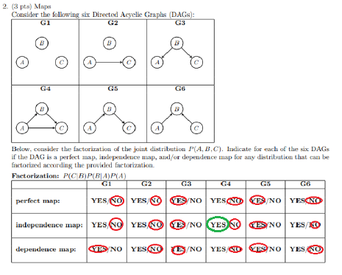

It relates to G4 from this question. My question should have been: what are the (in)dependencies of G4.

Question 3

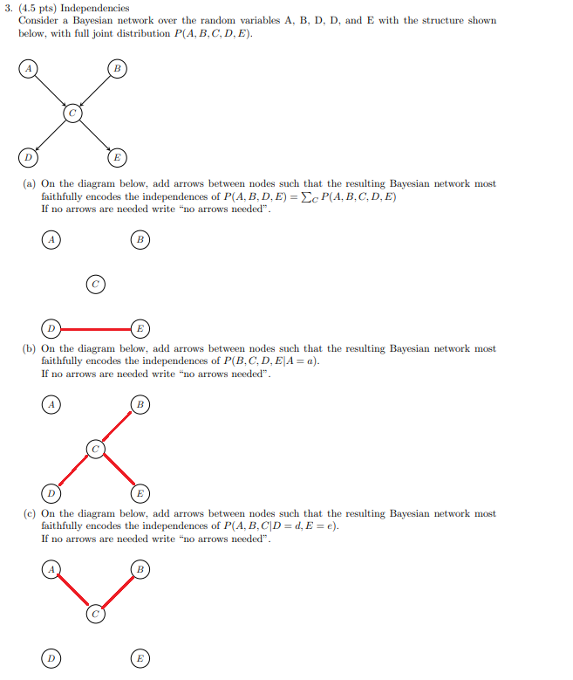

Question 4

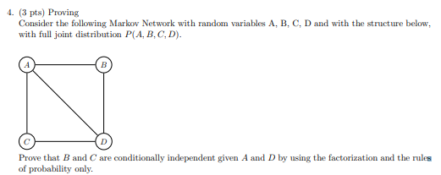

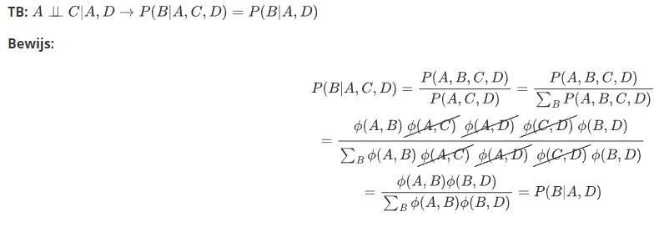

Question 5  
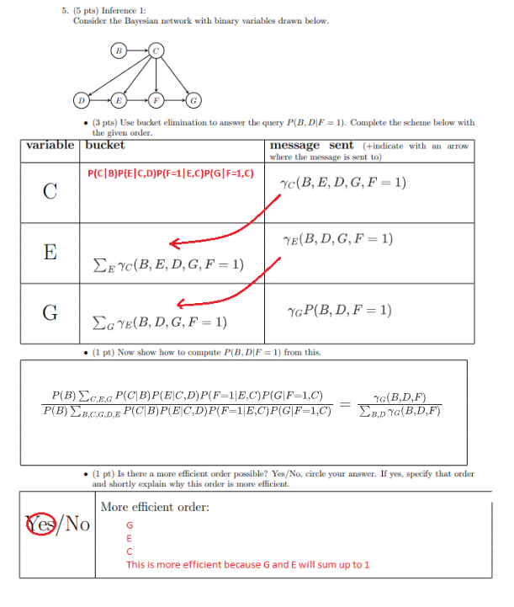

For second question: why denominator? How else would you solve it?

Question 6

